WebTables

Tables are one of the primary design tools for HTML documents. Tables allow for greater control over page layout, allowing creation of more visually interesting pages. Table has rows and columns to store the data. I guess 50% IT industry will come to a halt if Microsoft Excel stops working  that’s the importance of tables in organizing data. Search results on many websites are often displayed in the form of table. E.g. try searching for a flight between X and Y on a travel website, what you get is a table of results. There are times when we need to access elements (usually texts) that are within HTML tables. In this article let’s see how to read data from a Web Table using Selenium.

There are two types of HTML tables published on the web,

1. **Static tables**: Data is static i.e. Number of rows and columns are fixed.
2. **Dynamic tables**: Data is dynamic i.e. Number of rows and columns are NOT
3. fixed.Handling static table is easy, but dynamic table is a little bit difficult as rows and columns are not constant.

## Using X-Path to Locate Web Table Elements

Before we locate web element, first let's understands-

**What is a web element?**

Web elements are nothing but HTML elements like textbox, dropdowns radio buttons, submit buttons, etc. These HTML elements are written with **start** tag and ends with an **end** tag.

For Example,

**<p>** My First HTML Document**</p>.**

Steps for getting X-path of web element that we want to locate.

**Step 1)**In Chrome, Go to <http://money.rediff.com/gainers/bsc/daily/groupa>

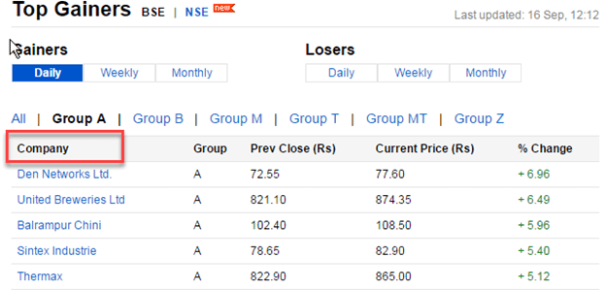

**Step 2)**Right click on web element whose x-path is to be fetched. In our case, right click on "Company" Select Inspect option. The following screen will be shown -

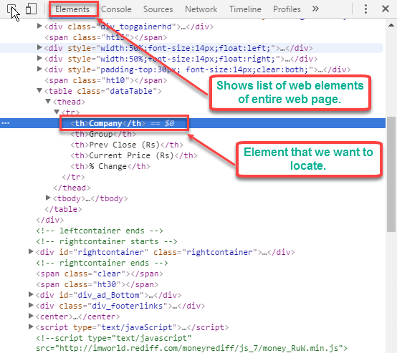

**Step 3)** Right Click on highlighted web element > Select Copy -> Copy x-path option.

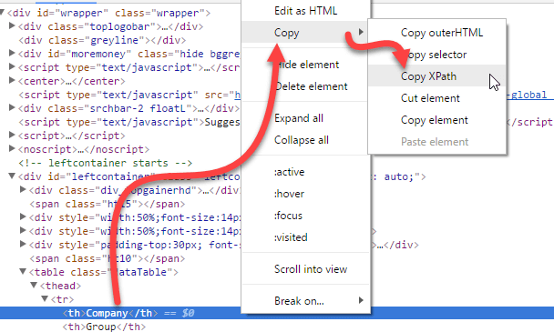

**Step 4)** Use the copied X-path "//*[@id="leftcontainer"]/table/thead/tr/th [1]" in Selenium WebDriver to locate the element.

## Example: Fetch number of rows and columns from Dynamic WebTable

When the table is dynamic in nature, we cannot predict its number of rows and columns.

Using Selenium web driver, we can find

* Number of Rows and columns of web table
* X row or Y column's data.

Below is program for fetching total number of rows and columns of web table

|  |
| --- |
| https://cdn.guru99.com/images/2-2017/050217_0717_HandlingDyn5.png |
| ScreenShot  import java.text.ParseException;  import java.util.List;  import org.openqa.selenium.By;  import org.openqa.selenium.WebDriver;  import org.openqa.selenium.WebElement;  import org.openqa.chrome.ChromeDriver;  public class Noofrowsandcols {  public static void main(string[] args) throws ParseException {  WebDriver wd;  System.setProperty("webdriver.chrome.driver", "D:\\ chromedriver.exe") ;  wd = new ChromeDriver();  wd.get("http://money.rediff.com/gainers/bsc/dailygroupa?");  //No.of Columns  List <WebElement> col = wd.findElements(By.xpath(".//*@id="leftcontainer']/table/thead/tr/th"));  System.out.println("No of cols are : " +col.size());  //No.of rows  List <WebElement> rows = wd.findElements(By.xpath(".//*[@id="leftcontainer']/table/tbody/tr/td[1]"));  System.out.println("No of rows are : " + rows.size());  wd.close();  }  **Code Explanation:**   * Here we have first declared Web Driver object "wd" &initialized it to chrome driver. * We use List <WebElement> to total number of columns in "col". * findElements commands returns a list of ALL the elements matching the specified locator * using findElements and X-path //*@id="leftcontainer']/table/thead/tr/th")); we get all the columns * Similarly, we repeat the process for rows.   **Output:** Example: Fetch cell value of a particular row and column of the Dynamic Table |

